 | 

Oregon Department of Transportation

TransInfo System



HBUD Extract Software Design

WBS 3.3.5.1

02v02

Exor Corporation Ltd 2010
Version Control
Date | Version | Changed by | Notes
January 2010 | 0.1 | RE | Initial revision
February 2010 | 0.2 | RE | Second Draft addressing ODOT comments
March 2010 | 1.0 | RE | Final version addressing changes requested.
March 2010 | 1.1 | RE | Second Final version addressing changes requested.
March 2010 | 2 | MK | Clean final version
August 2011 | 02v01 | JM | Add design change for UAT Issue 745
August 2011 | 02v02 | JM | Add design change for UAT Issue 745, (revised)
August 2011 | 02v03 | JM | Added Truncating comment section 7.4.5

Note:
- Version numbers < 1 indicate draft
- Whole numbers indicate a finalized edition
- Version numbers between whole numbers indicate error correction, minor changes altering the substance of the report
- Version numbers with 2 decimal points indicate draft to a minor or major revision.
- Draft changes prior to a major revision should be marked as “DRAFT”
- Version does not indicate acceptance by ODOT or Exor.

Cover Image: I5 Portland, Vaughan 2009.

Contents
Contents 3
Table of Figures 4
1. Introduction 5
2. Summary of HBUD Extract 5
3. Design Approach 7
4. Development Standards 7
5. TransInfo Data Structures 7
6. Major Components 8
7. Detailed Component Description 9
7.1 Foundation Components 11
7.1.1 Exor Application Roles 11
7.1.2 Exor Asset and Network Data (Standard Component) 11
7.2 Maintain Activity Information Process Flow 11
7.2.1 Modify HBUD Activity Data (User) 11
7.2.2 Modify Activity Data with Standard TransInfo Asset Management Forms (User Interface) 11
7.2.3 HBUD Activity Asset Type Metadata (Data) 12
7.2.4 Review HBUD Activity Data (User) 15
7.3 Create HBUD Extract 15
7.3.1 Initiate HBUD Extract Generation Process (User) 15
7.3.2 Folder on the Launchpad to Hold HBUD Buttons (User Interface) 15
7.3.3 Button to Call HBUD Extract Generation Process (User Interface) 15
7.3.4 Generate HBUD Extract File (Procedure) 16
7.3.5 Determine what Crews are to be Processed (Process) 16
7.3.6 For Each Crew Loop (Process) 16
7.3.7 Determine Extent (Process) 16
7.3.8 For Each Activity, Loop (Process) 16
7.3.9 Determine Asset Storage (Process) 16
7.3.10 HBUD Activity Asset Types (Data) 16
7.3.11 Count (Process) 17
7.3.12 Length (Process) 17
7.3.13 Summary (Process) 17
7.3.14 Calculation (Process) 17
7.3.15 Generate HBUD Extract Row (Process) 18
7.3.16 Write the Row to the Extract Table (Process) 18
7.3.17 HBUD Extract Data (Data) 18
7.3.18 All Activities Processed? (Process) 19
7.3.19 All Crews Processed? (Process) 19
7.3.20 Message to Indicate Success (User Interface) 19
7.3.21 Lump Sum (Process) 19
7.3.22 HBUD Extract Generation Complete (User) 19
7.4 Download HBUD Extract Process Flow 19
7.4.1 Request Download of HBUD Extract (User) 19
7.4.2 Folder on the Launchpad to Hold HBUD Buttons (User Interface) 19
7.4.3 Button on Launchpad to Initialize Process (User Interface) 19
7.4.4 Generate HTML Form to Allow Download (Procedure) 20
7.4.5 Generate Text File Ready for Download (Process) 20
7.4.6 Generate Html Form with Link Embedded (Process) 20
7.4.7 Form Prompting User to Save the File (User Interface) 21
7.4.8 Save HBUD Extract to File (User) 21
8. Security 21
9. Installation and Documentation Deliverables 21
9.1 Scripts 22
9.2 Documentation 22
10. Summary 22
Appendix 1 – Process Flow Diagram 23

Table of Figures
Figure 1 – Current Process to Update HBUD 6
Figure 2 – Proposed Process to Update HBUD 6
Figure 3 – High level Process Flow 9
Figure 4 - Detailed Process Flow 10
Figure 5 – Proposed HBUD Application Functions 15
Figure 6 – Proposed HBUD Application Functions 20
Figure 7 - HBUD Download Form 21

Introduction
The purpose of this document is to identify the design of the HBUD Extract that is being created as part of the TransInfo project for the Oregon Department of Transportation. It does this by defining the software components of the system, partitions them into developer subsystems and software components, defines and describes the components of each interface, and shows the associations with the user requirements and technology infrastructure.

The Oregon Department of Transportation (ODOT) is implementing an Exor Asset Management System to be called TransInfo. TransInfo will replace the existing ITIS and Features Inventory systems with a spatially enabled system that supports multiple LRS. It is based on COTS software from Exor Corporation and implementation is being carried out by a team consisting of staff from both Exor and ODOT.

HBUD is used by the maintenance group to plan and monitor budgets. A file must be compiled from data in TransInfo including asset records, their location on the network, and the associated ‘activities’. It must then be extracted and made available to ODOT to load into HBUD as a VSAM file.

The document is divided into the following sections after this introduction:
- Summary of HBUD Extract
- Design Approach
- Development Standards
- TransInfo Data Structures
- Major Components
- Detailed Component Description
- Security
- Installation and Documentation
- Summary

Summary of HBUD Extract
HBUD is a system used to produce the Highway Budget Report and is a mechanism used to generate budgets for crews. Each feature has activities associated to it, for example ‘ditches’ are associated to ‘ditch clearing’. The extract consists of a quantity of features per activity type. There is a requirement to store and link activity types to asset types and crosswalk table will be used to associate the activities to the individual features count. Currently this information is extracted from the Features Inventory (FI) system and imported into the HBUD system. This process is illustrated in Figure 1 – Current Process to Update HBUD below.

PAST

CURRENT

NEW

PAST

CURRENT

NEW
(Budget)
FI
HBUD
Figure 1 – Current Process to Update HBUD

TransInfo will replace the Features Inventory system so the extract will need to be generated from TransInfo instead. The process will be to generate a CSV file which is then used to generate a VSAM file which is then loaded to the HBUD system. This process is illustrated in below.

PAST

CURRENT

NEW
(Budget)

Asset
Data

and

Activity
Information
HBUD
Convert CSV to VSAM

TransInfo
TAD
Figure 2 – Proposed Process to Update HBUD

Design Approach
The process Exor uses to create a software design document is to first gather system requirements and these have been recorded in the document HBUD Extract System Requirments.doc and have been accepted by both Exor and ODOT. The system is then broken down into a process flow. The software design is then documented to follow the process flow each component of the software is detailed.

The HBUD Extract Software has been designed using a number of techniques to facilitate agreement and communication amongst each of the involved parties. The system process flow is recorded with the use of ‘swim lane’ diagrams. Swim lane diagrams allow the software designer to identify the components and processes required by the new software. A good description of swim lane diagrams can be found at: http://en.wikipedia.org/wiki/Swim_lane. Iterations of the swim lane diagram allow the software designer to modify the planned process to optimize it.

With the process clearly identified, the software designer can detail the process with further swim lanes as required and detail the software design to implement the process.

Exor has had extensive discussion with ODOT staff during the development of the HBUD extract Specification. The result of that and subsequent design work is a swim Lane Diagram shown in Appendix 1.

The result is this document which should contain enough detail for ODOT to assure themselves that the software will meet the identified requirements and for a software developer to create and deliver the software to ODOT.

Development Standards
The HBUD extract will be developed using standards defined by Exor’s Custom Development Code Custodian so as to be suitable for submission into Exor’s Source Code Repository. In general, this means using standard package headers, a naming convention, placing procedures and functions into packages and laying out the install package in the prescribed pattern.

The HBUD Extract software should be able to be installed by calling a single SQL script if at all possible and should not rely on users needing to enter the application to configure it.

A single script should be provided to completely uninstall the software if this is ever required.

TransInfo Data Structures
For a detail on the TransInfo Data Model refer to the document COTS Data Dictionary. Below is a brief discussion of areas of specific interest to HBUD.

Assets required for the extract are stored either as ‘summary’ asset types or in ‘detail’ assets. Summary assets record the number or other measure (such as total length) of a physical asset within the extent of a section of road. These sections are generically called ‘count sections’. All count sections are related to an EA group and all EA groups are related to crew groups. In this way it can be determined what sections of road (and what summary asset items) a crew is responsible for maintaining. There are six types of crew (section, bridge, electrical, striping, sign and landscape) and each has a set of summary assets, EA groups and crew groups.

Detail assets are maintained by the RICS unit. Each detailed asset records information about a single asset. In order to include these records in the HBUD extract the relevant point assets need to be counted and the continuous assets length summed that exist within the extent of the crew. In rare cases a calculation needed to be performed.

Rules that govern what is included in the extract are stored in a dummy asset type dedicated to this purpose.

Major Components
The HBUD Extract is a potentially complex set of software required to manage a relatively complex process. The high level process is mapped in Figure 3 – High level Process Flow below. Each component of this process is then discussed in further detail in the following sections of this document where swim lane diagrams have been used to separate the complex components in to parts small enough to design in detail sufficient to build the specified software.

The major components of the HBUD extract software are:

- A process to maintain the HBUD extract metadata that defines the asset/activity relationship
- A process to create a HBUD extract and store it in the database
- A process to save the HBUD extract to a file on the users client machine.

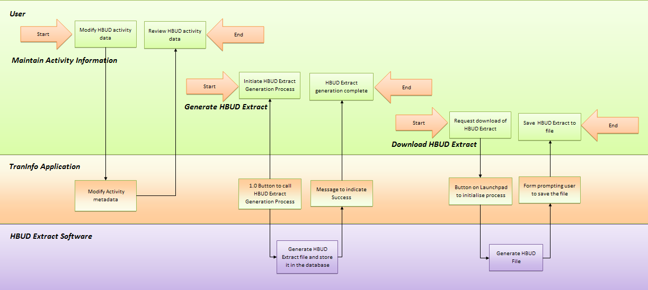

Figure 3 – High level Process Flow

Detailed Component Description
The process flow has been modeled as a series of swim lane diagrams. These are illustrated in Figure 4 - Detailed Process Flow and in larger format in Appendix I.
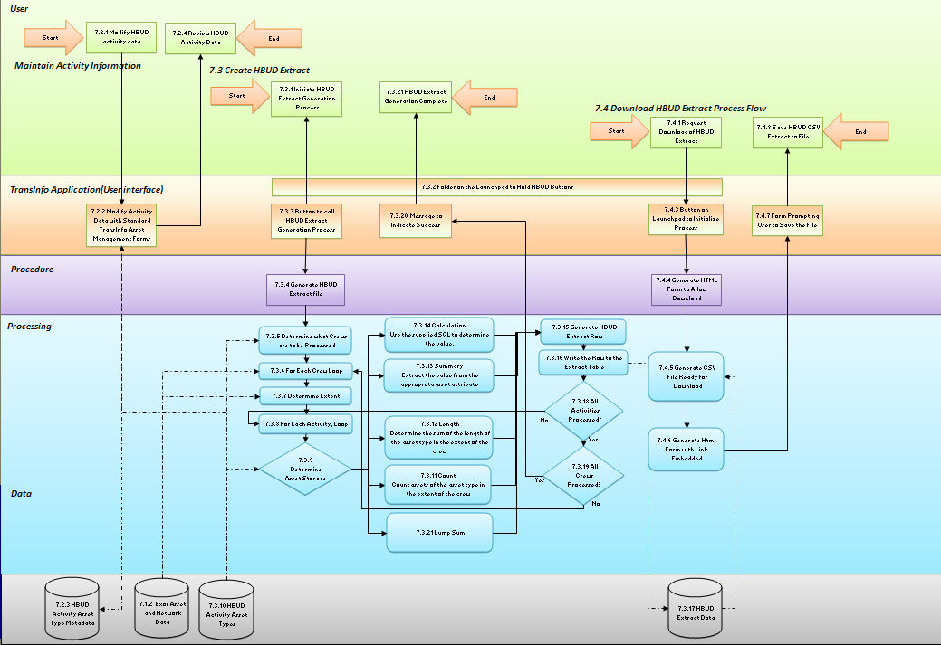
Figure 4 - Detailed Process Flow
In this section each object in the Design Swim Lane diagrams detailed with what the component does, what relationships it has and enough detail to allow a programmer to develop the code.

Foundation Components
Some components of the software are used many times and are not explicitly depicted in the swim lane diagram but are referenced by other components so they must exist. This includes the standard features of the TransInfo system but they are not detailed in the document and can be assumed to exist. Where these are referenced in this document they are marked as (Standard Component). This also includes other custom components being built as part of the TransInfo project, these are identified as such and the reader should refer to the applicable software design document.

Foundation Components required by the HBUD Extract process are documented here and will be constructed as part of the development of the HBUD Extract.

Exor Application Roles
The HBUD extract requires two roles. They are TI_APPROLE_HBUD_USER and TI_APPROLE_HBUD_ADMIN. They are used to control access to functions and data.

Exor Asset and Network Data (Standard Component)
The HBUD Extract process will read asset and network data stored within TransInfo. Refer to the COTS Data Dictionary document for detail.

Maintain Activity Information Process Flow
This process flow is used to maintain the ‘metadata’ needed to generate the HBUD extract. The most common activity will be to alter the asset to activity relationship but this metadata also holds other information. This metadata is held as a dummy asset type. This provides a convenient location to store this data and a simple but existing user interface to manipulate it with.

While this process flow requires very few components to be developed because it makes extensive use of the existing standard software, the process will need user and administration documentation.

START

Modify HBUD Activity Data (User)
A common task is to modify the activity data relationships. TransInfo Users will do this via the application. Only users who have the Role TI_APPROLE_HBUD_ADMIN should have access to this function.

Modify Activity Data with Standard TransInfo Asset Management Forms (User Interface)
The activity information will be stored as a dummy asset. The data will be entered by the ODOT using the standard asset management forms and loaders, and maintained with the same forms. The user will either modify the existing asset data or add additional records.

HBUD Activity Asset Type Metadata (Data)
During development this asset type needs to be established. The asset type should be configured with the following attributes:

Asset type: HACT
Asset Description HBUD Asset and Activity information
Admin unit type: SUM
Asset feature type: Point (not used)

Asset Roles:
TI_APPROLE_HBUD_ADMIN Mode: NORMAL
TI_APPROLE_HBUD_USER Mode: READONLY

Asset Network:
None

Asset Attributes:

Field Name | Field Type / Length | Notes | Example
ACTIVITY | VARCHAR2(3) | The activity defined by HBUD | 138
APPROPRIATION_  CODE | VARCHAR2(3) | Appropriation Code defined by HBUD | 010
TIME_TYPE | VARCHAR2(2) | The time type defined by HBUD, should use an appropriate LOV | 0
CALCULATION_  TYPE | VARCHAR2(30) | This attribute indicates how the feature information is stored in TransInfo and therefore should be extracted for HBUD. The valid values are:  Summary – the data is stored as the attribute in a summary asset  Count – the data is stored as an asset that should be counted (usually a point asset)  Length – the data is stored as a continuous asset and the total length of assets of that type should be summed  Calculated – the generation of the value is not recorded as a simple data item in TransInfo and needs to be calculated. The SQL to generate this is stored in the Attribute Values field (see below).  Lumpsum – the value will always be one with a unit of LUMP SUM | SUMMARY
ASSET_TYPE | VARCHAR2(4) | Asset type holding the required information  Should use an appropriate LOV generated from the list of asset types currently in use including relevant types maintained by the RICS group. If the value is dependant on the length of network in the crew then the appropriate summary asset can be used with the Calculation type of Length | SECS
ATTRIBUTE_TYPE | VARCHAR2(30) | The asset attribute holding the value for the summary asset  Or  The dependant attribute of the detailed assets | FENC_CNT
ATTRIBUTE_  VALUES | VARCHAR2(200) | The attribute value(s) that should be included when calculating ‘Length’ or ‘Count’. This must be a quoted and comma delimited list.  If ASSET_TYPE is null then all instances of the asset are counted, irrespective of the attributes and this field is ignored.  Or  For values that are marked as Calculated in the calculation type above an SQL rule must be entered in this field. This SQL will be run to determine the value.  For calculation types of ‘Summary’ this field will be ignored. | (null)
CREW_TYPE | VARCHAR2(4) | The type of Crew. The value should be one of the CREW network group types.  Should use an appropriate LOV | SECW
FEATURE_TYPE | VARCHAR2(30) | Feature type required by HBUD. | FENCE

Review HBUD Activity Data (User)
Users will use the standard Asset forms to review the HBUD activity data.

END

Create HBUD Extract

START

Initiate HBUD Extract Generation Process (User)
Periodically, users will need to regenerate the HBUD extract.

Folder on the Launchpad to Hold HBUD Buttons (User Interface)
In order to hold all the HBUD user functions, a folder will be created in the TransInfo Launchpad. This can be achieved by creating a HBUD ‘product’ in the HIG_PRODUCTS table (standard component) and adding an entry to the HIG_WEB_FAVORITES table (standard component).

Button to Call HBUD Extract Generation Process (User Interface)
A button on the Launchpad is required so the user can initialize the Generate HBUD Extract process. The accepted method of doing this is to create a GRI module (standard component), register it as a Hig_Module (standard component) with the role of TI_APPROLE_HBUD_USER, and add an entry to the Web Favorites table (standard component) so that the button will appear in the Launch Pad for the users with that role. The GRI module will refer to a procedure in its preprocessing attribute to call the code to initialize the ‘Generate HBUD Extract file’ procedure.

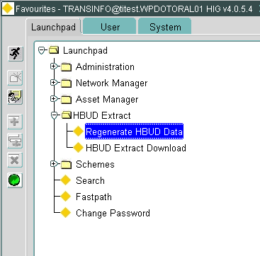
Figure 5 – Proposed HBUD Application Functions

Generate HBUD Extract File (Procedure)
A procedure stored in the database will hold a series processes to generate the HBUD extract and store it in a table in the Oracle database. These processes:

- Determine what Crews are to be Processed
- For Each Crew Loop
- Determine Extent
- For Each Activity, Loop
- Determine Asset Storage
- Count (Process)
- Length (Process)
- Summary (Process)
- Calculation (Process)
- Calculation (Process)
- Generate HBUD Extract Row
- Write the Row to the Extract Table
- All Activities Processed? (Process)
- All Crews Processed? (Process)
- Message to Indicate Success (User Interface)
- Lump Sum (Process)

These are described below in sections 7.3.5 to 7.3.21

Determine what Crews are to be Processed (Process)
The crew types to be processed are defined by the HBUD Activity asset type. All crews that are members of the crew network types listed will be processed.

For Each Crew Loop (Process)
For each crew that is an item of the crew types identified in the process above, loop through the following process.

Determine Extent (Process)
For each crew, determine the network extent of the crew so detailed assets may be counted or lengths summed or calculations applied based on that extent. The extent of the crew group is determined from the extent of it’s child ‘EA’ group.

For Each Activity, Loop (Process)
For each activity that is applicable to this crew type stored in the crew type attribute in the HBUD Activity asset loop through the following process.

Determine Asset Storage (Process)
Determine if the value is calculated from a count, length, summary or calculation with a lookup to the CALCULATION_TYPE attribute in the HBUD Activity asset and apply the appropriate process.

HBUD Activity Asset Types (Data)
The ODOT will enter rows into the dummy Activity Asset type and this will define the rules that determine what the extract contains. Refer Error: Reference source not found Error: Reference source not found.

Count (Process)
Count all assets in the crew extent (defined above) that are of the type defined in the ASSET TYPE attribute of the HBUD Activity Asset that have a attribute value in the comma delimited list contained in the ATTRIBUTE_LIST attribute of the HBUD Activity Asset. This list should be in the form where this count query can be constructed in the form:

SELECT COUNT(*) FROM ASSETS WHERE <ASSET_ATTRIBUTE> IN (<ATTRIBUTE_LIST>);

Where:
<ASSET_ATTRIBUTE> is the VIEW_COL value in the asset meta model for the asset type specified in the ASSET_TYPE field of the activity
<ATTRIBUTE_LIST> is a comma separated list of any possible data values in that attribute.

If ASSET_ATTRIBUTE is null then all instances of the asset are counted, irrespective of the attributes

Length (Process)
Sum the length of all assets in the Crew Extent (defined above) that are of the type defined in the ASSET TYPE attribute of the HBUD Activity Asset that have a attribute value in the comma delimited list contained in the ATTRIBUTE_LIST attribute of the HBUD Activity Asset. This list should be in the form where this sum query can be constructed in the form:

SELECT SUM(LENGTH) FROM ASSETS WHERE <ASSET_ATTRIBUTE> IN
(<ATTRIBUTE_LIST>);

Where:
<ASSET_ATTRIBUTE> is the VIEW_COL value in the asset meta model for the asset type specified in the ASSET_TYPE field of the activity
<ATTRIBUTE_LIST> is a comma separated list of any possible data values in that attribute.

If ASSET_ATTRIBUTE is null then all instances of the asset are counted, irrespective of the attributes

Summary (Process)
Sum the value of the attribute defined by the attribute ASSET_ATTRIBUTE in the HBUD Activity Asset of the summary asset type defines in the ASSET TYPE attribute of the HBUD Activity Asset.

It cannot be assumed that the asset type is a summary asset and that the crew ID is derivable via an ‘EA’ group type. This allows the values of a non summary asset to be summed. E.g. if ‘Fence’ where to become a detailed point asset with an attribute of ‘fence length’ this design will cater for that data model.

Calculation (Process)
A few activities require a value that is not derived with a simple count, sum of length or summary asset attribute. The current example is a calculation of equivalent bitumen miles which sum asphalt paved shoulder miles, where shoulders of less than 4’ wide are counted as 1/3 miles and those above 4’ are counted as 2/3 miles. The calculation will be defined as an SQL string and stored in the ATTRIBUTE_LIST attribute of the HBUD Activity Asset. The SQL will be run against the extent defined in the process above so the SQL sting will have a strict format and may not be able to run independently (i.e. it may not be a complete, valid SQL string). Exact structure will be defined during the software build but is anticipated that the SQL will be run as a sub query in a larger select statement and the SQL sting will have a strict output structure including defined column alias and will use predefined column alias’ to refer to the crew extent within its ‘where’ clause.

The calculation may not be user configurable without assistance from Exor, the rules required for the definition of the calculation will be documented in the Administration Guide.

Generate HBUD Extract Row (Process)
The processes described above generate all the data required for a row in the HBUD extract. This process assembles the row.

Each row consists of the following information which exactly matches the output required

Field Name | Field Type / Length | Definition to be used:
APPN | VARCHAR2(3) | The Appropriation Code from the HBUD activity asset.
CREW | VARCHAR2(4) | Crew ID
ACTIVITY | VARCHAR2(3) | Activity from the HBUD activity asset.
TIME_TYPE | VARCHAR2(2) | Time type from the HBUD activity asset.
UNIT_OF_MEASURE | VARCHAR2(20) | Unit of measure from the asset attribute, or ‘miles’ for length or ‘count’ for count or ‘LUMP SUM’ for lump sum items
FEATURE_TYPE | VARCHAR2(30) | Feature type from the HBUD activity asset.
FEATURE_COUNT | Number | The Result of the Count or Length or Summary or Calculation or LUMPSUM processes described above.

Write the Row to the Extract Table (Process)
The HBUD extract row is written to a database table.

HBUD Extract Data (Data)
The current HBUD extract will be stored in a new table within the TransInfo schema called XODOT_HBUD_EXTRACT. It will have the following structure:

Field Name | Field Definition
APPN | VARCHAR2(3)
CREW | VARCHAR2(4)
ACTIVITY | VARCHAR2(3)
TIME_TYPE | VARCHAR2(2)
UNIT_OF_MEASURE | VARCHAR2(20)
FEATURE_TYPE | VARCHAR2(30)
FEATURE_COUNT | Number

All Activities Processed? (Process)
If all the activities listed for the current crew type have been processed then proceed, otherwise process the next activity.

All Crews Processed? (Process)
If all the Crews have processed then proceed to indicate success, otherwise process the next crew.

Message to Indicate Success (User Interface)
When the generation of the HBUD extract is complete, and all data has been written to the database table, the user should be notified that the process is complete. This is usually achieved with a pop up box. A message box can be produced using the function:

RAISE_APPLICATION_ERROR(-20000,'HBUD Generation Complete');

Lump Sum (Process)
Enter 1 as the feature amount and LUMP SUM as the units.

HBUD Extract Generation Complete (User)
User has completed the generation of the HBUD extract.

END

Download HBUD Extract Process Flow
START

Request Download of HBUD Extract (User)
The user will instigate the process to download and save the current HBUD extract. No development required.

Folder on the Launchpad to Hold HBUD Buttons (User Interface)
This component is described in Create HBUD Extract.

Button on Launchpad to Initialize Process (User Interface)
A button on the Launchpad is required so the user can initialize the Extract download process. The accepted method of doing this is to create a GRI module (standard component), register it as a Hig_Module (standard component) with the role of TI_APPROLE_HBUD_USER, and add an entry to the Web Favorites table (standard component) so that the button will appear in the Launch Pad for the users with that role. The GRI module will refer to a procedure in its preprocessing attribute to call the code to initialize the ‘Generate HTML form to allow download’ procedure.

Figure 6 – Proposed HBUD Application Functions

Generate HTML Form to Allow Download (Procedure)
A procedure stored in the database which will call two processes. The first will assemble a text file and the second will make that file available in a HTML form so the user can download the data.

Generate Text File Ready for Download (Process)
This process will generate a text file from the table of data generated by the Generate HBUD Extract process flow and stored in the HBUD Extract Data table in the database. This process should perform any data manipulation or formatting to produce the file. The format to be used will be a CSV File. This is a simple text file with data separated by commas with any text strings at quoted with double quotation marks.. No header row will be attached to the file. The contents of the file will exactly match the extract format prescribed in the Generate HBUD Extract process flow, Generate HBUD Extract Row process, above and the end of each line will contain a CRLF characters (chr(13)chr(10)) The extracted data for the feature count will be Truncated to 2 decimal places.

Generate Html Form with Link Embedded (Process)
The procedure should then create and display a HTML page to the user containing a link to download the text file. The HTML page will be constructed using the nm3web package (standard component). The HTML page will be delivered to the user via the Data Access Descriptor (DAD) (standard component). A sample form layout is displayed below in Figure 7 - HBUD Download Form with the file in the process of being downloaded.

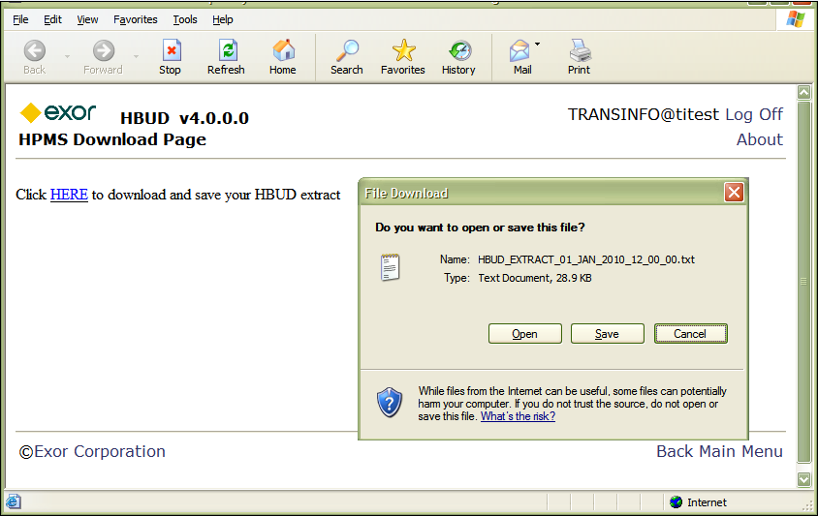
Figure 7 - HBUD Download Form

Form Prompting User to Save the File (User Interface)
This form is constructed using the process described above. The user may be asked to enter a username and password if this is the first time the HTML forms. The file is available as a hyperlink in the form and when the user clicks on the link they are prompted to save the file.

Save HBUD Extract to File (User)
The user is responsible for saving the file to the client machine where ever they see fit. No components need be built to support this.

END

Security
This function should only be accessible to applicable users. This could be only the person responsible for loading the HBUD extract. To control this, the application function to produce the export should be restricted to those with an application role dedicated to controlling access to this function. This role would be called TI_APPROLE_HBUD_USER.

Installation and Documentation Deliverables
The following will be produced as part of the development effort to support the software described above

Scripts
  - Process to install all application components
  - Process to remove all application components

Documentation

Documentation is required to:

- Install and uninstall the application function
- Maintain the application function. This would consist of altering the activities associated with each asset.
- Creating and downloading the HBUD Extract

For convenience these may be combined into one document.

Summary
The HBUD extract will be produced from the TransInfo System including associating the asset attributes to activities. TransInfo will produce a CSV format file for the process and ODOT staff will convert that to a VSAM file so it can be loaded to HBUD.

The design documented above has been produced by Exor and will be used by an Exor developer to create software that provided all the inputs, functions and outcomes required by the HBUD specification document including documentation.

Appendix 1 – Process Flow Diagram

< HBUD_Design_Appendix_1.1_final.xls >

